12 December 2025

Dear Parents and Carers,

It’s a joyful end to a busy term, as we move into our final week. I wanted to share a few key dates and events with you — with a particular focus on an important milestone for our Year 11 students.

• Monday: We are proud to be hosting the Dixons Northwest Athletics Competition. It’s a privilege to welcome schools from across the region and to showcase our students, staff and facilities.

• Monday at 5:00pm: Christmas Showcase. We are thrilled to invite you to a magical evening celebrating the creativity and talent of our students. The showcase will feature performances from across the Performing Arts, including music, drama and dance, and promises to be a fantastic start to the festive season.

• Wednesday: Year 7 Trip to see Matilda. This is a wonderful enrichment opportunity and one the students are very much looking forward to.

• Thursday: Year 11 Results Day. This is a significant moment for our Year 11 students, who will be receiving their results officially. The day will be structured and purposeful, with time built in for reflection, celebration, and clear target-setting as they look ahead to the next stage of their GCSE journey.

• Thursday: Christmas Jumper Day and Christmas Dinner Day in the canteen.

•Friday: End of term arrangements. Students will be dismissed by year group from 1:45pm, with all students off site by 2:00pm unless they have an after-school correction. Corrections will run as usual on this day.

A message for our Year 11 families

Year 11 has reached the point in the year where small habits make a big difference. After an intense term, students absolutely deserve time to rest, recharge and enjoy Christmas with their families. That rest matters. Alongside that, we strongly encourage students to find some quiet, structured time for light revision over the holiday period, so they return in January confident and ready to build momentum. The habits they sustain now will directly shape the options and choices available to them by the summer — and our aim is for every student to leave us with the very best possible outcomes.

Please also note that we will be holding our Year 11 Parents’ Evening when we return on Thursday 8 January. This is an important opportunity to discuss progress, agree next steps, and make sure every student has a clear plan for the final stretch.

Community support

I would also like to say a heartfelt thank you to Miss Simms for the outstanding work she has led this term in supporting our most vulnerable families. Through developing our relationship with Cash for Kids, organising our Christmas Foodbank, and leading the staff Christmas Toy Drive, she has ensured that many of our students will not miss out this Christmas.

As families prepare to celebrate Christmas, I would like to take this opportunity to wish you all a warm, peaceful and joyful festive period. Thank you for your continued support throughout the term — it makes a real difference to our young people.

Warmest wishes,

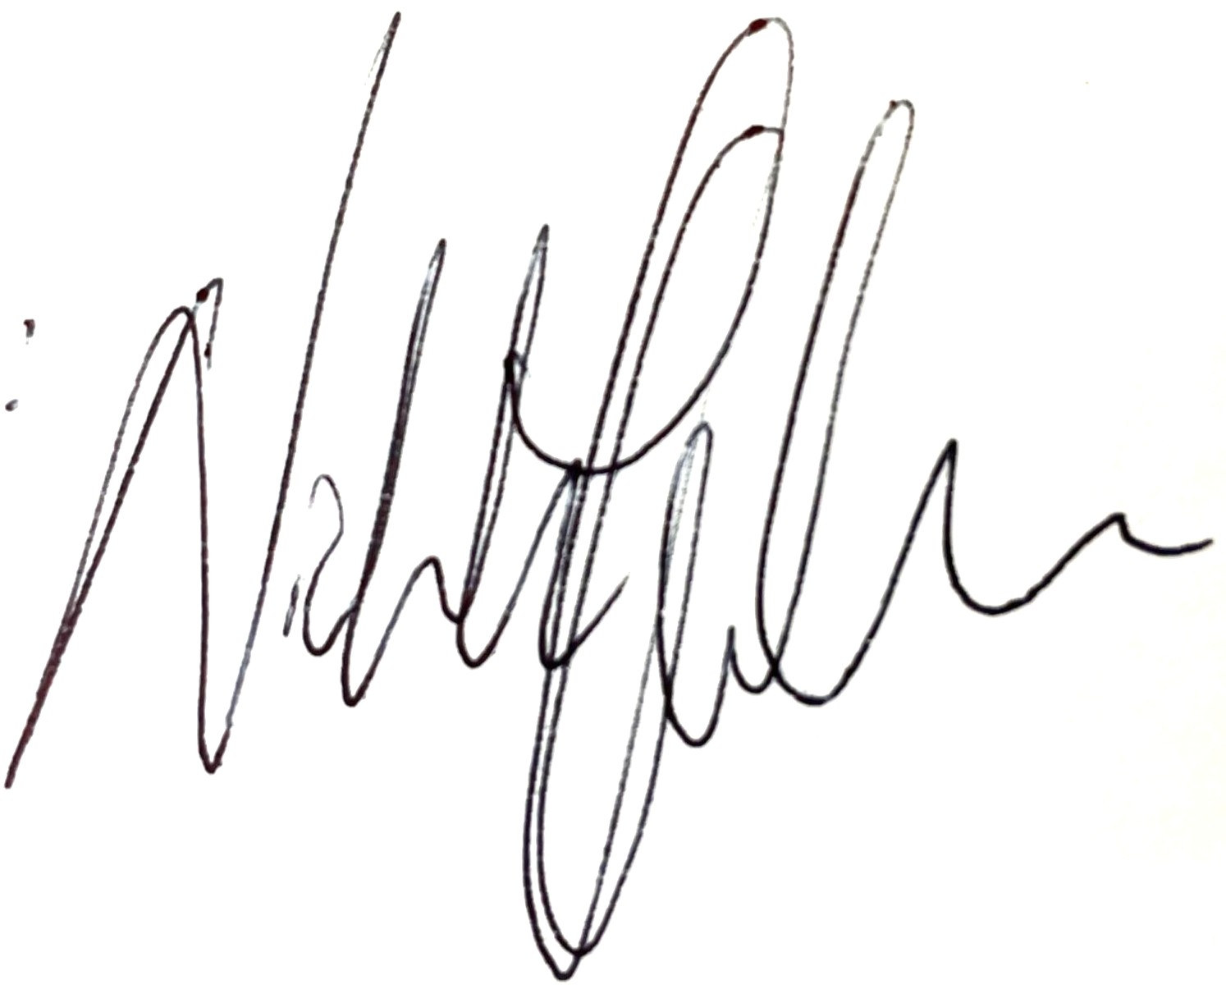

Nick Hughes
Principal
Dixons Fazakerley Academy

